Step I: Which uses data from the calibration phase of the experiment to train 6 common spatial pattern filters.

1. Incoming data is filtered to remove low frequency drift and high frequency noise (leaving 1<Hz<40)
2. Unused channels are removed
3. Average across EEG channels (1:32) is computed and subtracted from each single channel to obtain the common average referenced data.
4. Data are separated based on ‘relax’ (walk, class A) and ‘imaginary movement’ (run, class B) triggers
5. These epochs are segmented every 500 ms into 1,000 ms epochs.
6. 1,000 ms epochs are filtered within 5 different bands: delta (2-4 Hz), theta (4-7), alpha (7-12), beta (13-29) and gamma (30-40), and one complete band (1-40 Hz).
7. These 6 different bands from 2 different classes are used to train 6 different spatial filters. The idea behind these is that at each frequency band, the channels that can dissociate between the two classes (‘useful variance’) will increase in amplitude whereas channels in which the variance cannot distinguish between the classes is decreased.

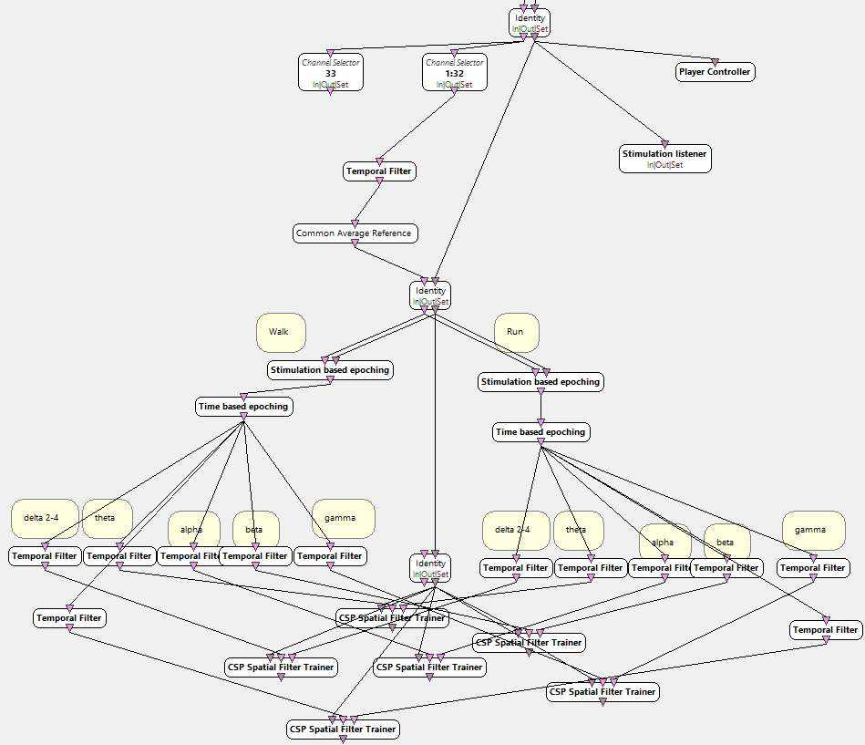At the end of the operation, we thus have 6 different spatial filters.

Step II: Which uses the data from the calibration phase, and from the 6 different spatial filters to do machine learning:

1-6: As before

1. Spatial filters from step I are applied
2. The amplitude is squared
3. The amplitude is averaged
4. A log transform is applied to normalize the data: 1+log(x)
5. Feature vectors from class A and B comprising 6 x 32 = 192 features are submitted to the feature aggregators
6. These are then used by the machine learning algorithm, currently SVM type C-SVC degree 3, linear kernel, epsilon 0.1, tolerance 0.001, cost 1, cache 100, gamma 0, nu 0.5, with shrinkage.

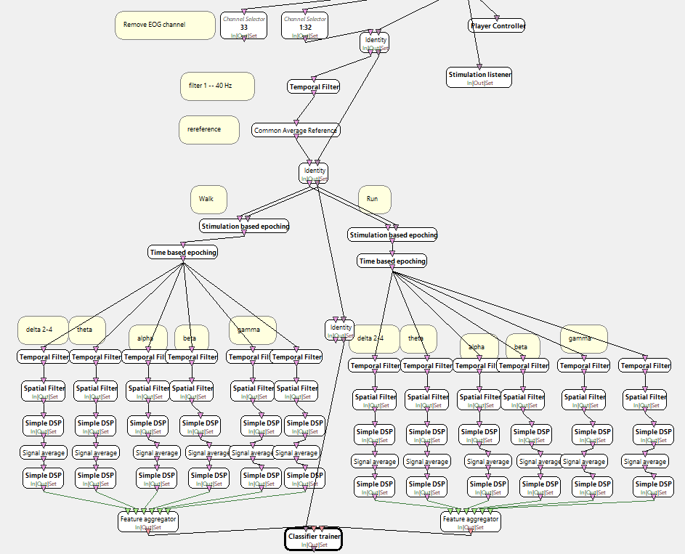

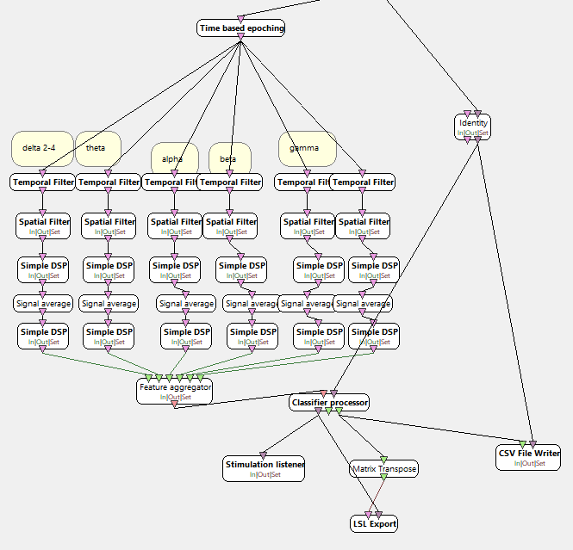Step III: We do the same as step II except without step 4, the data are just segmented every 0.5 seconds into 1 second epochs. The machine trained in previous step 12 is now used to classify new data.